**P250/1**

**GEOGRAPHY**

**(PHYSICAL GEOGRAPHY)**

**PAPER 1**

**OCT 2022**

**3 hours**

**PRE-UNEB Set 1**

**ALLIED GEOGRAPHY TEACHERS EXAMINATIONS 2022**

***Uganda Advanced Certificate of Education***

**GEOGRAPHY PAPER 1**

**3 HOURS**

**INSTRUCTIONS TO CANDIDATES**

* Answer ***four*** questions.
* Section ***A*** is compulsory
* At least ***one*** question should be answered from section ***B*** and ***one*** question from section ***C***.
* Credit will be given for use of relevant sketch maps, diagrams and specific examples studied in the field.

# SECTIONA

Questions **1** and **2** are compulsory

# COMPULSORY MAP WORK QUESTION:

Study the EAST AFRICA 1:50,000(UGANDA), **KABALE** Map extract; Series Y732, sheet, 93/4; Edition 4-U.S.D. and answer the questions that follow.

(a) (i) Give the grid reference of Ndaragi trigonometrical station in the North. (01 mark)

(ii) Name the feature found at grid reference 327557. (01 mark)

(b) (i) Determine the distance ofa loose surface road from Kabala cemetery to Kamuganguzi Grid square 3357 (01 mark)

(ii) Calculate the area of Kitumba sub-county shown on the map extract. (02 marks)

(iii) Giving evidence from the map, state the direction flow of river Karujabura and tributaries. (02 marks)

(c) Draw a reduced sketch map 2.5times the size of the area shown on the map extract and on it mark and name the following:

(i) Rusoorooza plantation

(ii) Lake bunyonyi

(iii) Permanent swamps

(iv) Communication types

(v) Relief types. (10 marks)

(d) Giving evidence from the map, account for the development of:

(i) Drainage pattern formed by river Mujera and tributaries. (03 marks)

(ii) Rusoorooza plantations (04 marks)

**2. COMPULSORY PHOTOGRAPHIC INTERPRETATION:**

Study the photograph provided and answers the questions that follow 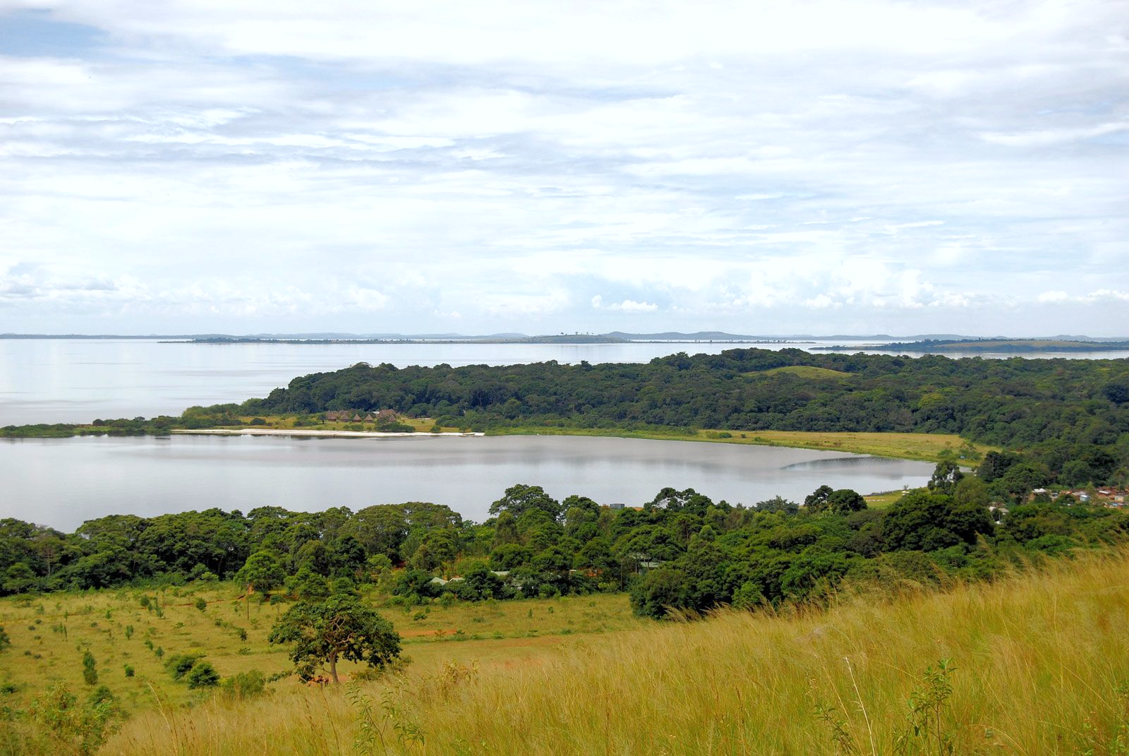

a) Draw a landscape sketch map of the area shown on the photograph and on it name;

(i) Headlands and bays;

(ii) Vegetation types;

(iii) Settlements

(iv) Beach (9 marks)

b) Account for the formation of the dominant features in the middle ground. (7 marks)

c) Describe the characteristics of the vegetation seen in the photograph. (7 marks)

d) Giving reasons to your answer, suggest any **one** area in East Africa where the photograph could have been taken from. (2 marks)

SECTION B

3. Discuss the evidences of the present day distribution of continents and position of basins. (25 marks)

4. To what extent are the lake formations in East Africa caused by Tectonic activities? (25 marks)

5. (a) Distinguish between marine water regressions and transgressions. (06 marks)

(b) Examine effects of marine water transgressions on landscapes in East Africa. (19 marks)

SECTION B

6. Account for the difference in the Temperature in East Africa. (25 marks)

7. To what extent is altitude influencing the distribution of Forest vegetation in East Africa? (25 marks)

8. (a) Differentiate between soil catena and soil profile. (10 marks)

(b) Explain the factors affecting the development of soil profile in East Africa. (15 marks)

**END**